Lecture 00: Induction Week

Slightly expanded induction information

Dr. Gordon Wright

September 25, 2023

# Induction Overview

## Welcome back and welcome to Research Methods!

## This year you become Scientists!

This year, in Research Methods, you will perform your first piece of REAL psychological research

In groups, you will:

* Identify an area of psychological research
* Review and critique the literature in this area
* Develop a testable hypothesis
* Design a 2x2 ANOVA experiment unique to you (within your group study)
* Obtain Ethical Approval for your experiment
* Collect REAL data
* Analyse these data
* Write up the results in APA format

## A full overview will be given in the first lecture!

Do not worry! It’s going to be a great adventure!

## A ‘warm up’ for your Y3 Dissertation

* The same 20-week timeline
* The same skills and techniques you will need
* Careful step-by-step guidance and support in the lab setting
* Scaled-down experiments and write-ups
* The security of working in a group
* Tips and advice from world-class researchers
* Opportunity to think carefully about your final year Dissertation, and how to crush it!!

## Support and guidance

* Gordon Wright (Module Coordinator and floating Enthusiast in Chief)
* 6 gobsmackingly amazing Lab Tutors
* Your Personal Tutor and your PT group
* AND EACH OTHER!!

This is a team-sport

## me

I will be in every Research Methods lecture and I have a Student Hour from 1-2(tbc) every Monday.

Available at g.wright@gold.ac.uk

I genuinely couldn’t imagine anything I would rather do that this. Please talk to me and help me get to know you!

## Module weighting and assessment

Research Methods has a 30 credit weighting, meaning that the Mini-Dissertation contributes 10x the developmental essay. Keep that in mind.

To pass, you must pass all 3 assessment elements:

* + Critical Proposal 1,800 words (15%)
  + Mini-Dissertation 2,500 words (70%)
  + CHIP Learning Log 1,200 words (15%)

## A friendly warning

|  |  |
| --- | --- |
|  | **Warning**  All coursework is INDIVIDUAL and subject to normal plagiarism and collusion rules. AI can (and likely should) be used for many aspects of the research process, and these will be indicated and guidance offered. However, the use of Generative AI to produce written work that you submit is not acceptable. Don’t make the mistake of falling for the superficially charming output of even the more advanced LLMs, it will not follow the requirements we impose, and it could hallucinate, and how would you know? Don’t risk it. |

## Module structure

1 x 1 hr Lecture per week (Monday 11-12 PSH LG02 (winter term))

1 x 2 hr Lab per week (Tuesday - see personal timetable)

4 x Personal Tutor meetings across the year

## Weekly Structure

Each week there will be a very brief **Overview** to set out the main topics and to give you a set of milestones or preparatory activities designed to keep you on track.

**Lecture** (slides available as a Reveal Slideshow via Quarto and as pdf, docx, and if you wish for anything else, please just ask.)

## Labs

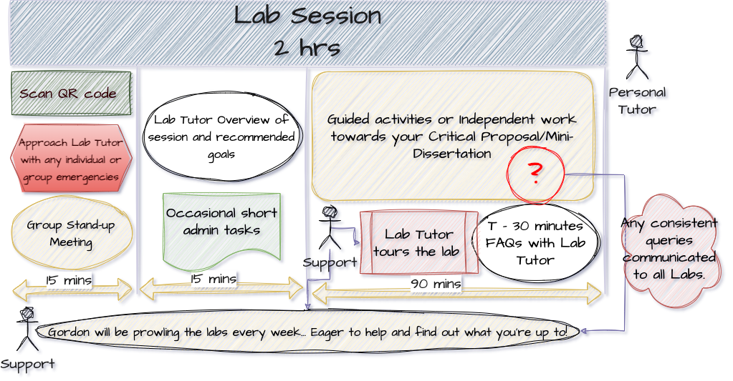

Lab structure

* **Lab Notebook** - find a solution that works for you, but make sure that you have it every week, so a cloud-based system would be best. You will be expected to show notes of your progress to your Lab Tutor
* Lots can be achieved in the labs, but independent study and coordinated group work will be required. We will be asking about this aspect of the process regularly.

## DangerZone



All hail the Kenny!

“You’ll never say hello to you,  
Until you get it on the red line overload.  
You’ll never know what you can do,  
Until you get it up as high as you can go!”

Dangerzone - Loggins, K.

Most weeks, there will be extra morsels - called the DangerZone [in honour of the best movie ever made (Top Gun) and the Yacht-Rock and fashion icon legend Kenny Loggins].

## Highway to the Dangerzone

DangerZone are opportunities to consider aspects of research procedure beyond the level expected for this year, but ‘on the table’ for next year and any future research endeavours.

They are research-based in a loose sense - they will include programming, literature search and management, academic and knowledge management tools, tips and hacks that might (or might not) be of interest or useful.

If the term is going well, they might even be fun. All ideas welcome.

## Coursework

The courseworks ALL require critical reflection and meta-cognitive practice. This will be discussed in a number of lectures, but it contributes to effective learning and your integration of the skills and experience of doing this research exercise.

## Time management and teamwork

..will both be required.

I ask you to see both as an opportunity to develop these important skills.

You will see we have some ideas to make this more relevant to careers and employability

It is easier to ‘keep up than to catch up’.

## Resources

We will be releasing a series of valuable resources to help you through every step of the process

These will have value for your final year dissertation too.

Contribution to and comment on these is welcome and hoped for!

Open Educational Resources will be used extensively, and most core readings are available online via the library.

## Before Lab 1, please…

Add an email signature to your college email, including your student number, programme, lab tutor, and personal tutor. It will speed up responses to any emails you send to staff.

## Thank you for your time

And have an amazing year!

The Research Methods Team